**DSP – Experiment 14**

**Decimation in Time Domain**

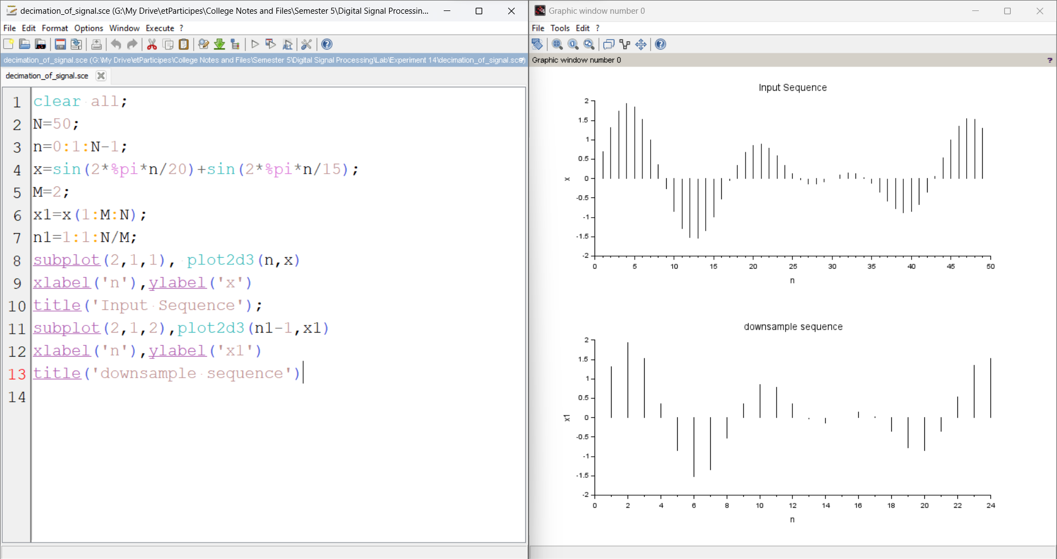

**Decimation in Frequency Domain**

